Online Portfolio
Supervisor User Guide

Page 2 Logging in

Page 2 Home page

Page 3 Profile

Page 4 Accessing portfolios

Page 5 Receiving tasks (i.e. trainee competencies)

Page 5-6 Reviewing tasks

Page 6 Signing off competencies (or returning to trainee)

Page 7 Competency tasks for personal tutors

Page 7 Using the Gap Analysis

Page 7 Getting more help and guidance

LOGGING IN
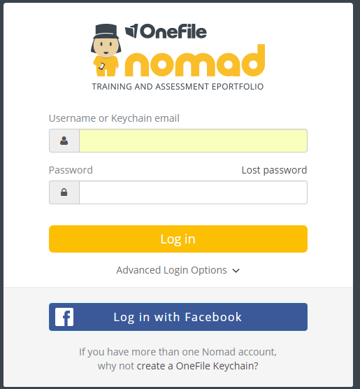
- Type your Username in here. Lancaster
DClinPsy will have sent you this

- Type the Password sent to you here
(this is an encrypted password which
you will be prompted to change after
you have logged in)

- Click on Log in

CLINICAL SUPERVISOR HOME PAGE

- At the top right hand side of the home page are icons where both
Message Alerts and Tasks and can be accessed

On the left-hand side of the home page are icons which link to trainees, reports and resources.
- Click on the ‘hamburger’ to expand the section - this will explain each icon

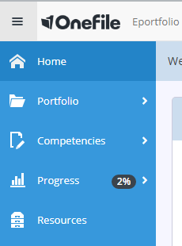

PROFILE
The first task the trainee will receive will be to update their profile.
- To upload a profile picture, click on Upload

- The below window will open

- Click on choose file

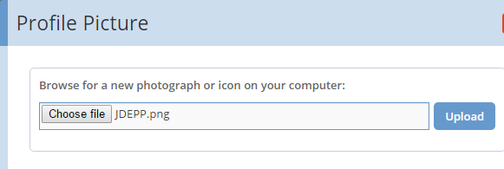

- Locate the picture which you want to use for your profile

- Click on open

- Click on upload to use this picture

- Complete any other relevant fields on the profile page

ACCESSING PORTFOLIOS
To check progress or view a trainee’s portfolio, the Clinical Supervisor has two options:

Option One
- Click on the any cohort dropdown option and select the cohort required
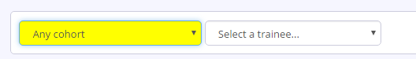

- Select the relevant trainee
This will open the selected portfolio.

Option Two
The Trainee Dashboard section will display all trainees assigned to the Clinical Supervisor.
- Click on the trainee’s name - this will open the selected portfolio
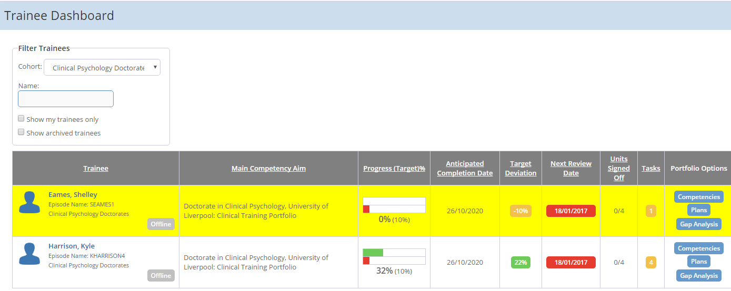

RECEIVING TASKS (TRAINEE COMPETENCIES)
The Clinical Supervisor will be required to sign off competencies sent to them direct from the trainees.
These will be added as tasks and highlighted in the notification area at the top of the screen.

REVIEWING CLINICAL SUPERVISOR TASKS
- Click on the tasks icon
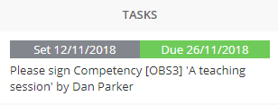
This will open a list of tasks
- Click on the task

The competency will open
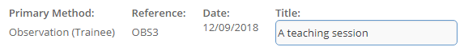
- Scroll to the evidence section
The trainee will either provide evidence direct in the area below or via an attachment
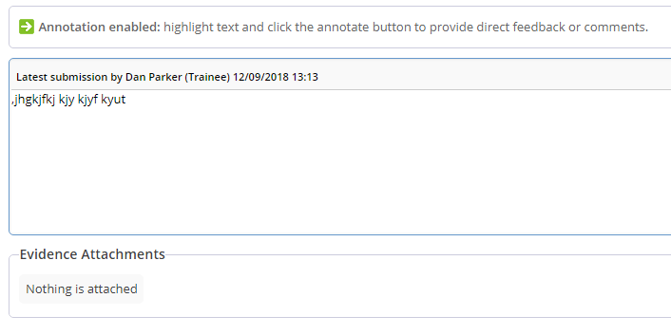
- The trainee will have selected the criteria that the evidence provided has met.
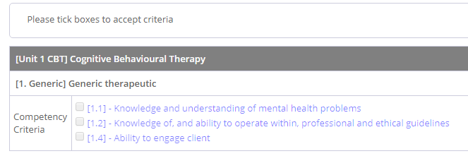

- The clinical supervisor ticks in each box to confirm the competency has been met.

- The clinical supervisor can feedback or provide comments in the relevant box as well as annotating the evidence provided if required

SIGNING OFF COMPETENCIES (OR RETURNING TO TRAINEE)

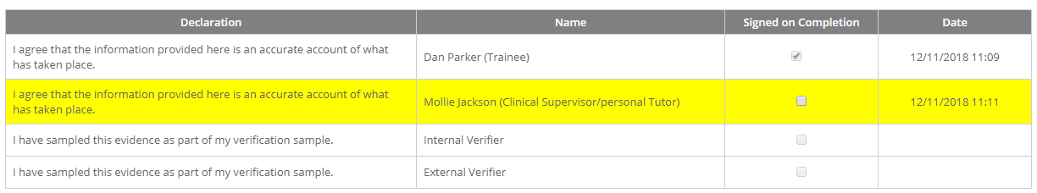

- If the clinical supervisor is happy with the evidence and selected competencies, tick the signature box next to their name and click on save and quit.

- If the clinical supervisor is not accepting the competency, click to sign the competency, but click on resubmit.

COMPETENCY ASKS FOR PERSONAL TUTORS

All competencies covered specifically by work undertaken at the university will be directed directly to trainees’ personal tutors to approve by the trainee.

USING THE GAP ANALYSIS

A clinical supervisor can see what criteria is outstanding by using the gap analysis feature
- Select the relevant trainee/portfolio
- Click on the Progress Tab
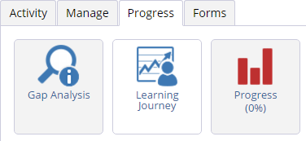
- Click on the Gap Analysis icon

The gap analysis page will open
- Click on Not Completed
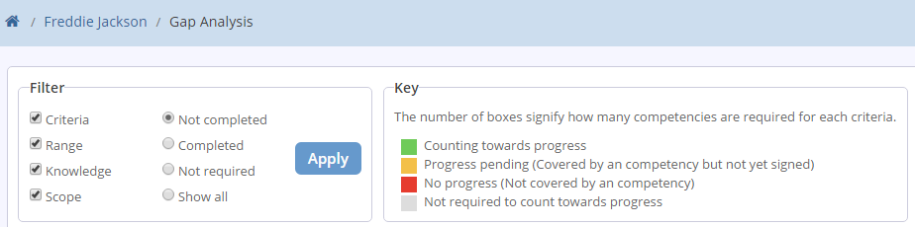
- Click on Apply

- Competencies awaiting sign off or those a trainee is still working will show a yellow box
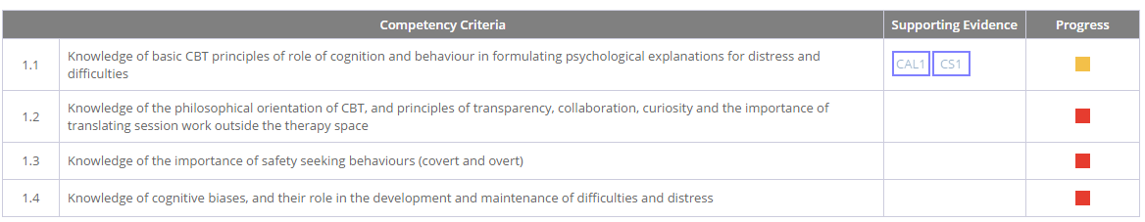

- Criteria outstanding and still requiring completion will show a red box

GETTING MORE HELP AND GUIDANCE

Detailed guides to the portfolio are available directly in the system. From the homepage, scroll down to the Other Options section and click on the User Guides link.

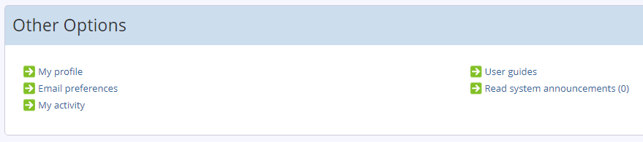

If you have a query you cannot find the answer to, please do get in touch with Rob Parker at the Lancaster programme via r.j.parker@lancaster.ac.uk

